**2023 Physics Deferred Paper**

1.

A student carried out a laboratory experiment to investigate the relationship between the force applied to a system of masses and the acceleration of the system. During the experiment a constant force was applied to the system and the acceleration was measured.

The experiment was repeated a number of times using a different applied force each time. The student was careful to ensure that the mass of the system being accelerated was kept constant.

The data recorded were used to draw the graph shown.

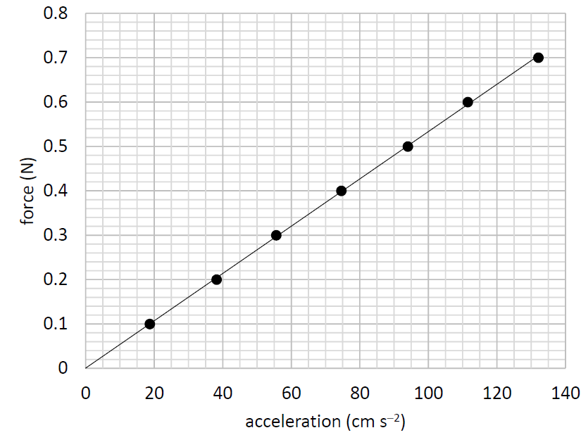

1. Draw a labelled diagram of how the apparatus was arranged in this experiment.
2. Using your diagram or otherwise, explain
   1. what quantities need to be measured so that the acceleration can be calculated
   2. how the student calculated the acceleration.
3. How did the student measure the applied force?
4. How did the student ensure that the applied force was the only force accelerating the system?
5. Why did the student ensure that the mass of the system was kept constant?
6. How did the student ensure that the mass of the system was kept constant?
7. Using the graph above, calculate the mass of the accelerated system in kilograms.

2.

A student carried out an experiment to measure the specific heat capacity of water. 61 g of water at 10 °C was placed in a container of negligible heat capacity. Energy *E* was supplied to heat the water and *θ*, the temperature which the water reached, was recorded. This was repeated a number of times with different values of *E* supplied to equal masses of water. The student was careful that the water had an initial temperature of 10 °C each time.

The data were recorded in the table below.

|  |  |  |  |  |  |  |
| --- | --- | --- | --- | --- | --- | --- |
| *E* (J) | 1273 | 2552 | 3823 | 5107 | 6376 | 7642 |
| *θ* (0C) | 15 | 20 | 25 | 30 | 35 | 40 |

1. How could the energy have been supplied to the water?
2. Describe two precautions that the student should have taken to ensure that *θ* was measured accurately.
3. Describe how the container of water might have been insulated.
4. The student used a container of negligible heat capacity.

What is the significance of the fact that the container had negligible heat capacity?

1. Using the data provided, draw a suitable graph on graph paper of E against *Δθ*, the change in temperature of the water.
2. Calculate the slope of your graph.
3. Use your slope to find the specific heat capacity of water.

3.

A student was given a box that contained both converging lenses and diverging lenses.

The teacher asked the student to determine f, the focal length of one of the converging lenses.

The student chose a converging lens from the box. First, an approximate value of its focal length was measured. Then a suitable object was used to form an image on a screen and the object distance u and the image distance v were measured. This process was repeated for different values of u and v, which were recorded in the table below.

|  |  |  |  |  |
| --- | --- | --- | --- | --- |
| *u* (mm) | 150 | 200 | 250 | 300 |
| v (mm) | 169 | 135 | 119 | 108 |

1. Why would the method described for this experiment not work for a diverging lens?
2. How did the student determine which lens was a converging lens?
3. How did the student find an approximate value for the focal length?
4. Draw a labelled diagram of how the apparatus was set up to measure *u* and *v*.
5. Label the distances *u* and *v* on your diagram.
6. Describe two precautions that the student should have taken to ensure that *v* was measured accurately.
7. Use all the data provided to calculate an average value for *f*.

4.

A student investigated the relationship between the resistance *R* of a piece of metal wire and its temperature *θ*. The data were recorded in the table below.

|  |  |  |  |  |  |  |
| --- | --- | --- | --- | --- | --- | --- |
| *θ* (0C) | 10 | 20 | 30 | 40 | 50 | 60 |
| *R* (Ω) | 0.188 | 0.194 | 0.203 | 0.209 | 0.213 | 0.220 |

1. Draw a labelled diagram of how the apparatus was arranged in this experiment.
2. Draw a suitable graph on graph paper to show the relationship between R and *θ*.

The student carried out research to identify the material that the wire is made from and found the values for the resistivity ρ of various materials at a temperature of 300 K, as shown below.

|  |  |  |  |  |  |  |
| --- | --- | --- | --- | --- | --- | --- |
| material | aluminium | constantan | copper | nichrome | steel | tin |
| *ρ* (nΩ m) | 26.5 | 490 | 17.0 | 120 | 150 | 110 |

1. Convert 300 K to °C.
2. Use your graph to find the resistance of the wire at 300 K.
3. The wire is found to have a length of 0.221 m and a diameter of 0.46 mm.

Name a suitable device that could have been used to measure the diameter of the wire.

1. Use the data to calculate the resistivity of the wire at 300 K.
2. Identify the material that the wire is made from.

5.

A student investigated the variation of current *I* with voltage *V* for a semiconductor diode in forward bias. The student set up a suitable circuit and recorded the data shown in the table below.

|  |  |  |  |  |  |  |  |
| --- | --- | --- | --- | --- | --- | --- | --- |
| *V* (V) | 0 | 0.25 | 0.5 | 0.55 | 0.6 | 0.65 | 0.7 |
| *I* (mA) | 0 | 0.04 | 0.21 | 0.44 | 1.5 | 4.48 | 14.24 |

1. Draw a circuit diagram for this experiment.
2. How did the student vary the voltage?
3. How did the student ensure that the diode did not overheat?
4. Draw a suitable graph on graph paper to show the variation of *I* with *V* for the semiconductor diode.
5. Identify the junction voltage of the diode.
6. The student was then asked to investigate the variation of *I* with *V* for a semiconductor diode in reverse bias. What changes should have been made to the circuit for a diode in reverse bias?

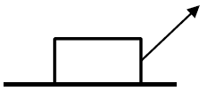6. Answer any eight of the following parts, (a), (b), (c), etc.

1. A child drags a box across a horizontal floor with a force of 44 N applied at 47° to the horizontal. The friction between the box and the floor is 20.5 N.   
   Calculate the net horizontal force on the box.
2. Write an expression for the acceleration *a* of a body oscillating at the end of a spring in terms of the mass m of the body, the spring constant k, and the displacement *s* of the body from its equilibrium position.
3. When exercising, an athlete loses body heat through perspiration at a rate of 300 W.

Calculate the mass of perspiration that needs to be evaporated from the athlete each minute to account for this heat loss.

1. A stretched string vibrates at a fundamental frequency of 205 Hz when the tension applied is 5 N. Calculate the fundamental frequency of the string when the tension applied is 10 N.
2. A person holds a curved metal spoon at arm’s length and rotates it slowly. On one side of the spoon the image seen is inverted and on the other side the image is upright. Explain why.
3. The refractive index of a diamond is 2.41. Calculate its critical angle.
4. Explain the principle of operation of polaroid sunglasses and how they help the wearer.
5. 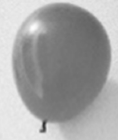State the colours of *(i)* the live wire, *(ii)* the neutral wire and *(iii)* the earth wire in a plug.  
   Sketch a graph to show how current varies with the voltage applied across the vacuum in a cathode ray tube.
6. Explain why a balloon that has been rubbed vigorously on a woolly jumper can stick to a wall.
7. Calculate the maximum moment of the couple in a basic d.c. motor when a current of 0.13 A flows through a square piece of wire of side 5 cm in a magnetic field of 0.22 mT.
8. (i) Explain why the existence of the neutrino was first proposed.

or

(ii) What is an electromagnetic relay? State one use of an electromagnetic relay.

latent heat of vaporisation for perspiration = 2426 kJ kg–1

7.

1. State Archimedes’ principle.
2. Describe a laboratory experiment to demonstrate Archimedes’ principle.
3. Steel is denser than water. A steel bar sinks when it is placed in water.

Explain why.

1. A boat which is made mostly of steel floats in water. Explain why.

A sealed balloon contains 7.75 g of air and has a volume of 6000 cm3 when it is at the surface of the sea.

It is dragged down to the sea floor at a depth of 37 m.

The temperature of the air in the balloon stays constant at 4 °C.

1. Calculate the density of air at the surface of the sea.
2. Calculate the total pressure acting on the balloon when it is at a depth of 37 m.
3. State Boyle’s law.
4. Calculate the density of the air in the balloon at a depth of 37 m.
5. The balloon is released from the sea floor.   
   Draw a force diagram to show the forces acting on the balloon as it rises through the water.

density of seawater at 4 °C = 1028 kg m–3; acceleration due to gravity = 9.8 m s–2;

atmospheric pressure at sea level = 101.3 kPa

8.

X‐rays and visible light are both part of the electromagnetic spectrum.

1. What is the electromagnetic spectrum?
2. Draw a labelled diagram of an X‐ray tube.
3. The working voltage of an X‐ray tube is 65 kV.

Calculate the maximum energy of the X‐rays that can be produced in this X‐ray tube.

1. What property of X‐rays makes them suitable for use in diagnosing a broken bone?



Helium was first observed by the French astronomer Jules Janssen in 1868.

He made careful measurements of the line emission spectrum from the Sun using a recent invention, the spectrometer. He observed a bright yellow line whose wavelength did not match any known element found on Earth at that time. It was later found to belong to the spectrum of helium.

1. Draw a labelled diagram of a spectrometer.
2. State three adjustments that should be made when setting up a spectrometer.

A spectrometer and an appropriate light source are used to investigate the line emission spectrum of helium. The light is passed through a diffraction grating of 600 lines per mm. The angle between the two second order images of the yellow line is found to be 89.67°.

1. Calculate the wavelength of the yellow light.
2. Explain why this diffraction grating is not suitable for use with X‐rays.

9.

1. State the law of radioactive decay.
2. What is meant by the term half‐life?

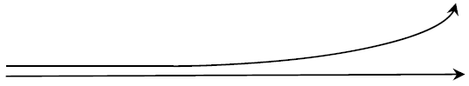Alpha radiation and gamma radiation enter a magnetic field together, with their direction of travel perpendicular to the field. The paths of the two types of radiation just after they enter the magnetic field are shown below.

1. Name the type of radiation that travels in a straight line in the magnetic field.
2. Justify your answer.
3. Use Fleming's left‐hand rule to determine the direction of the magnetic field.
4. Uranium–235 is an unstable isotope of uranium and decays by alpha emission.

Explain the term isotope.

1. Write a nuclear equation for the decay of uranium–235.
2. A sample of uranium–235 containing 7.69 x 1015 atoms has an activity of 0.24 Bq.

Calculate the half‐life of uranium–235.

A sample of uranium–235 was trapped inside a crystal many millions of years ago.

The sample is analysed to estimate how many half‐lives have passed since the uranium was trapped.

The sample is found to have 1.5625% of the original sample of uranium–235 remaining.

1. Calculate how many half‐lives have passed since the uranium was trapped in the crystal.
2. How many years ago was the uranium trapped in the crystal?

10.

Many electronic devices use direct current and relatively low voltages. However the current coming to our homes and businesses is a 50 Hz alternating current at a voltage of 230 V.

Electric current can be shown to have a magnetic effect.

1. State the two other effects of an electric current.
2. Describe a laboratory experiment to demonstrate the magnetic effect of an electric current.
3. What is meant by voltage?
4. Calculate the maximum voltage of a 230 V alternating source.
5. An oscilloscope may be used to show alternating voltage.   
   Draw a diagram to show how alternating voltage is displayed on the screen of an oscilloscope.



Many electronic devices use a charger to charge a battery which supplies the low voltages required.

One type of charger steps the alternating voltage down using a transformer.

1. Explain the operation of a transformer.
2. A transformer with a primary coil of 200 turns has an input voltage of 230 V. Calculate how many turns are needed in the secondary coil to give an output voltage of 5.75 V.

Some newer chargers make use of an electronic circuit to increase the frequency of the voltage.  
This means chargers are not as big and heavy as they once were.  
A coil of wire of area 0.42 cm2 with 80 turns is placed in a magnetic field with magnetic flux density changing at a frequency of 127 kHz.

1. Calculate the voltage induced in the coil as the magnetic flux density changes from a maximum of +2.6 mT to a minimum of –2.6 mT.

11.

John Tyndall from Leighlinbridge, Carlow was born in 1820. His major scientific interest was the interaction of light with matter. Among his many achievements was his discovery of the Tyndall effect, which led to the explanation of why the sky is blue. He realised that the colour of the sky is related to the scattering of light from the Sun by particles in the atmosphere.

1. Name the colour in the spectrum of white light that has the longest wavelength.
2. Light from the Sun can give rise to a rainbow.   
   State two conditions necessary for an observer to see a rainbow.
3. The distance between the Sun and the Earth is often given in astronomical units (au).

1 au = 1.496 × 1011 m.   
At a particular time of the year, the distance between the Sun and the Earth is 1.011 au.

Calculate, in minutes, the time it takes for light to travel from the Sun to the Earth at that time of the year.

The Sun is often described as the primary source of energy for the Earth. The Sun’s energy comes from nuclear fusion reactions. One of the main fusion reactions is described by the following nuclear equation: $$H_{1}^{2}+H_{1}^{1}→{He}_{2}^{3}$$

1. Calculate the energy released during this reaction.
2. As well as by direct heating from the Sun, the Earth can also be heated due to the greenhouse effect.

Explain how the greenhouse effect heats the Earth.

1. The greenhouse effect has both positive and negative consequences for human life on Earth.

Explain why.

In honour of John Tyndall, the Tyndall National Institute was established in Cork in 2004.

A research team at the Tyndall Institute have investigated the transmission of light of wavelength 2 μm in optical fibres.

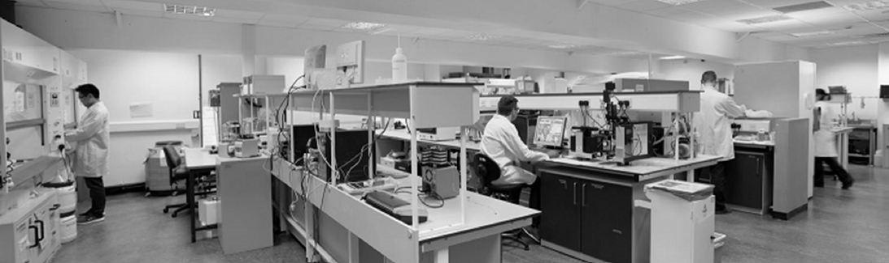

(vii) Calculate the energy of a photon that has a wavelength of 2 μm.

(viii) What phenomenon allows light to travel in an optical fibre without escaping?

12.

Answer either part (a) or part (b).

(a)

Atmospheric particle physics is a major field of research. Gamma radiation from deep space creates electron‐positron pairs in the Earth’s atmosphere.

1. What is a positron?
2. Name a detector suitable for detecting gamma radiation and describe the principle of its operation.
3. Write an equation to represent the creation of an electron‐positron pair by gamma radiation.
4. Electrons and positrons are both leptons. What is a lepton?

Scientists also investigate high energy collisions using circular accelerators at CERN.

Two protons, each with kinetic energy of 6.8 TeV, and travelling in opposite directions are collided together. After the collision various new particles are detected, as well as the two protons.

1. Calculate the maximum total mass these new particles can have.

Two of the particles that have been detected after high energy collisions are the sigma particle and the kaon.

1. A particular sigma particle is made of an up quark, a down quark and a strange quark.
   1. What type of hadron is this sigma particle?
   2. What charge does this sigma particle have?
2. A particular kaon is made of a down quark and an anti‐strange quark.
   1. What type of hadron is this kaon?
   2. What charge does this kaon have?

Engineers at CERN are planning to build a new circular accelerator with a greater radius.

In a circular accelerator a large magnetic field of flux density *B* is used to keep a particle of charge *q* and mass *m* travelling in a circle of radius *r*.

1. Write an expression for the tangential velocity *v* of the particle in terms of *B*, *q*, *m* and *r*.
2. Suggest a reason why engineers are planning to build a particle accelerator with a greater radius.

(b)

The semiconductor industry has grown to become one of the most important industries in modern society.

The development of semiconductors and integrated electronic circuits has led to a range of new devices which have changed the way people live.

1. What is a semiconductor?
2. Sketch the graph to show the variation of resistance with temperature for a semiconductor thermistor.

Rectification is an important process in modern electronics.

1. A semiconductor diode can be used as a half‐wave rectifier. Explain the term ‘halfwave rectifier’.
2. A bridge rectifier can provide full‐wave rectification. Draw the circuit diagram of a bridge rectifier.
3. What device can be used to smooth the current from a bridge rectifier?

A rectifier can be used to produce the direct current needed by a transistor.

1. Describe with the aid of a labelled diagram the basic structure of a bi‐polar transistor.

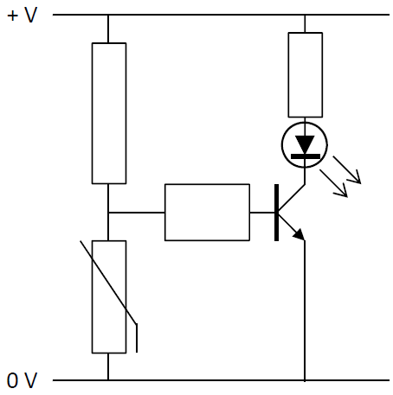

1. The diagram below shows a thermistor used in a transistor circuit. Explain what happens in the circuit when the thermistor is kept at a low temperature.
2. Logic gates are the basic building blocks of digital electronic circuits.   
   Draw a circuit diagram to show how a transistor can be used to make a NOT gate.

(ix) Draw the truth table for a NOT gate

13.

Read the following passage and answer the accompanying questions.

Almost any time physicists announce that they’ve discovered a new particle what they’ve actually spotted is resonance. Resonance is at the heart of things as diverse as music, nuclear fusion in dying stars, and even the existence of subatomic particles.

A parent pushing a child on a playground swing is a familiar example of resonance. Another example is when a singer shatters a glass with a sustained note. For a flute, there are specific resonant frequencies of sound waves that exactly fit inside the cylindrical shape.

In 1925, Erwin Schrödinger derived an equation for the hydrogen atom whose solutions are waves oscillating at a set of natural frequencies. Quantum theory revealed that the structure of atoms, no less than the structure of symphonies, is intimately tied to resonance. Electrons bound to atoms are a little like sound waves trapped inside flutes.

Quantum theory also showed us that light, which had been thought of as an electromagnetic wave, sometimes behaves like a particle, a photon. Meanwhile, matter‐particles such as electrons can exhibit wave‐like behaviour.

Resonance is also critical to nuclear fusion reactions. The most famous of these nuclear resonances enables the fusion of three identical helium nuclei into one carbon nucleus. Without this, stars would not be capable of producing carbon, and life as we know it would not be possible.

Adapted from: <https://www.quantamagazine.org/how‐the‐physics‐of‐resonance‐shapes‐reality‐20220126/>

1. What is meant by resonance?
2. Describe a laboratory experiment to demonstrate resonance.
3. The motion of a playground swing can be thought of as a simple pendulum undergoing simple harmonic motion. Calculate the resonant frequency of a swing of length 1.5 m.
4. A flute acts as a tube open at both ends.   
   Draw a labelled diagram to show the standing wave, vibrating at its fundamental frequency, produced in a flute.
5. A drinking glass can be modelled as a cylindrical pipe of length 15 cm that is closed at one end.   
   Calculate the fundamental frequency that would cause the glass to resonate and possibly even shatter.
6. Einstein’s explanation of the photoelectric effect depends on the concept of light behaving as photons. Outline Einstein’s explanation of the photoelectric effect.
7. At the start of the 20th century, both Niels Bohr and Erwin Schrödinger developed their models of the atom. Describe the Bohr model of the atom. (A labelled diagram may help your answer.)
8. Write a nuclear equation for the production of a carbon–12 nucleus, as described in the passage.

acceleration due to gravity = 9.8 m s–2; speed of sound in air = 343 m s–1

14. Answer any two of the following parts (a), (b), (c), (d).

(a)

1. What is meant by displacement?
2. The formula *s* = *ut* + ½*at*2 is a version of one of the equations describing linear motion.

Explain what each letter stands for in this equation.

1. Derive this equation.
2. Describe the assumptions which make this equation valid.
3. A student throws a small stone off a bridge.   
   She throws the stone vertically upwards with a speed of 6 m s–1.   
   It lands in the water, which is 19 m below the bridge.

Calculate the time the stone is in the air.

acceleration due to gravity = 9.8 m s−2

(b)

1. Define resistance.

A student set up a Wheatstone bridge to find the resistance of a piece of wire. A series combination of a 2 Ω resistor and a 3 Ω resistor is put in parallel with another series combination of a variable resistor and the piece of metal wire.

1. Draw a circuit diagram of this Wheatstone bridge.
2. Describe how the student checked that the Wheatstone bridge was balanced.
3. The Wheatstone bridge was balanced when the variable resistor had a resistance of 5 Ω.

Calculate the resistance of the piece of metal wire.

1. Apart from measuring resistance, state one other practical use of a Wheatstone bridge.

(c)

1. What is the Doppler effect?
2. Describe a laboratory experiment to demonstrate the Doppler effect.



A car travels along a road at a constant velocity, emitting an engine sound of constant frequency. An observer by the side of the road measures the frequency of the sound to be 303 Hz as the car approaches and 272 Hz as the car moves away.

1. Calculate the speed of the car.
2. Calculate the frequency of the engine sound heard by the driver of the car.

Speed of sound in air = 343 m s–1

(d)

1. What is meant by capacitance?
2. Describe a laboratory experiment to demonstrate how the capacitance of a parallel‐plate capacitor varies with the distance between the plates.
3. Draw a diagram of the electric field between the plates of a charged parallel‐plate capacitor.



1. The keys on some modern keyboards act as parallel‐plate capacitors.   
   When the key is pressed, the distance between the plates is changed.

A parallel‐plate capacitor has a capacitance of 0.12 pF when the distance between its plates is 5 mm.   
Calculate its capacitance when the distance between its plates changes to 0.3 mm.